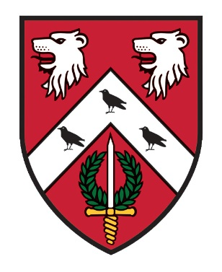
St. Anne’s College
Catering Department
2021/22
OPENING TIMES

Dining Hall - Monday – Friday - Breakfast – 08.00 – 09.30
Lunch – 12.15 – 13.45
Dinner – 18.15 – 19.30
Saturday - Brunch – 11.00 – 13.00
Sunday - Sunday Roast – 12.00 – 14.00
(On occasions these times may vary so please remember to keep checking your emails, the noticeboards in Hartland corridor or in the entrance to the Dining Hall)

STACS - Monday - Friday - 10.00 – 17.00

Bar - Tuesday - Saturday - 19.00 – 23.00
(with 20 minutes “drinking up time”)

To make purchases in the Dining Hall, STACS & Bar you will need to ‘top up’ your University card in advance (there is no overdraft facility on your card), using your SSO at
https://meals.st-annes.ox.ac.uk/meals/
The screen will give you a choice of topping up your food account or your bar account

***

STACS
HAS HAD A BIT OF A MAKEOVER, COME DOWN AND CHECK IT OUT!
Missed breakfast, or just wanting a coffee whilst working on your laptop, this is the place for you!

Due to popular demand we have brought back!
- Homemade Pizza with your choice of toppings
- Homemade Panini, Baguettes and Toasties

Other items available are:-
- Hot & Cold Drinks, Cakes & Snacks

If you have specific dietary requirements please ask a member of staff who will be able to help you.
Payment can be either University card or debit/credit card.

DATES FOR YOUR DIARY!
MICHAELMAS TERM
Formal Hall –
22nd October 2021 (Wk2)
4th November 2021 (Wk4)
19th November 2021 (Wk6)
2nd December 2021 (Wk8) CHRISTMAS DINNER (No Guests)

HILARY TERM
Formal Hall –
28th January 2022 (Wk2)
10th February 2022 (Wk4) FOUNDERS’ DINNER (No Guests)
25th February 2022 (Wk6)
10th March 2022 (Wk8)

TRINITY TERM
Formal Hall –
6th May 2022 (Wk2)
19th May 2022 (Wk4)
3rd June 2022 (Wk6)
16th June 2022 (Wk8) FAREWELL

***
ONLINE MEAL BOOKING

Go to https://meals.st-annes.ox.ac.uk/meals/ on your PC or mobile phone QR code below.
- Meals available to book online are Formal Hall & Subject Family Events.
- The meal booking system allows you to book in for dinners up to ten days in advance and closes two days prior to the event at 11.00hrs.
- You are able to specify for each meal what type of meal is required ie meat, vegetarian, vegan or specify any other dietary requirements for both you & your guests.
- Up to 3 guests can be registered for Formal Halls. No guests are allowed to Subject Family Events.
- You will need to bring your University Card with you to dinner. The system checks those attending the dinner have pre - booked.
- Please remember to request ‘with wine’ if required at Formal Hall and to book your seat on the table plan.

