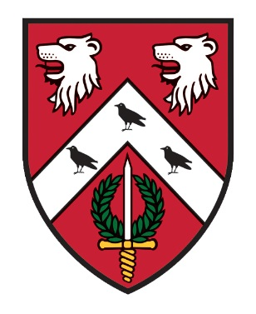
St. Anne’s College
Catering Department
2023/24
OPENING TIMES

Dining Hall - Monday – Friday - Breakfast – 08.00 – 09.30
Lunch – 12.15 – 13.45
Dinner – 18.15 – 19.30
Saturday & Sunday - Brunch – 11.00 – 13.00

(On occasions these times may vary so please remember to keep checking your emails, the noticeboards in Hartland corridor or in the entrance to the Dining Hall)

STACS - Monday - Friday - 10.00 – 17.00

Bar - Tuesday - Saturday - 19.00 – 23.00
(with 20 minutes “drinking up time”)

To make purchases in the Dining Hall, STACS & Bar you will need to ‘top up’ your University card in advance (there is no overdraft facility on your card), using your SSO at
https://meals.st-annes.ox.ac.uk/meals/
The screen will give you a choice of topping up your food account or your bar account

***

STACS
COME DOWN AND CHECK IT OUT!
Missed breakfast, or just wanting a coffee whilst working on your laptop, this is the place for you!

We serve -
- Homemade Pizza with your choice of toppings
- Homemade Panini, Baguettes and Toasties

Other items available are:-
- Hot & Cold Drinks, including wine and beers
- ‘Barefoot Bakery’ Cakes
- Snacks
- NEW Homemade ice creams and sorbets

If you have specific dietary requirements please ask a member of staff who will be able to help you.
Payment can be either University card or debit/credit card.
DATES FOR YOUR DIARY!
MICHAELMAS TERM
Formal Hall –
20th October 2023 (Wk2)
2nd November 2023 (Wk4)
17th November 2023 (Wk6)
29th November 2023 (Wk8) Graduate CHRISTMAS DINNER (No Guests)
30th November 2023 (Wk8) UG CHRISTMAS DINNER (No Guests)

HILARY TERM
Formal Hall –
26th January 2024 (Wk2)
8th February 2024 (Wk4) FOUNDERS’ DINNER (No Guests)
23rd February 2024 (Wk6)
7th March 2024 (Wk8)

TRINITY TERM
Formal Hall –
3rd May 2024 (Wk2)
16th May 2024 (Wk4)
31st May 2024 (Wk6)
13th June 2024 (Wk8) FAREWELL (No Guests)

***
ONLINE MEAL BOOKING

Go to https://meals.st-annes.ox.ac.uk/meals/ on your PC or mobile phone QR code below.
- Meals available to book online are Formal Hall & Subject Family Events.
- The meal booking system allows you to book in for dinners up to ten days in advance and closes two days prior to the event at 11.00hrs.
- You are able to specify for each meal what type of meal is required ie meat, vegetarian, vegan or specify any other dietary requirements for both you & your guests.
- Up to 3 guests can be registered for Formal Halls. No guests are allowed to Subject Family Events.
- You will need to bring your University Card with you to dinner. The system checks those attending the dinner have pre - booked.
- Please remember to request ‘wine or non-alcoholic drink’ if required at Formal Hall and to book your seat on the table plan.

